A Greek man and a Gothic man could put outside their inner space in a direct way, but our present-day man, with his individual consciousness, has to travel through the same way, but now this is not so easy.
Today gods do not assist us to create directly those spaces. Now we have to go through this inner way by ourselves, individually. And in my opinion. this is the main task of our time, that is to say, to know our inner space, because otherwise all those things that we can imagine as a form, with our old tools, with our old instruments, are going to be deceitful and void. Our spirit needs new spaces, but we have to create them with a new spirit. This new spirit may be creating right now, under this dark dome, as a very delicate germ which we will see when the light shines again.
At any rate, I have a proposal.

I wonder how we can build, with iron, glass and crystallised forms, something that is living spirit, something that is blood, if the living quality of blood makes it so elusive. I had imagined some things like the water, some cathedral of water, but perhaps, as a human meeting, the centre of synthesis may be space charged with future, with tensions of human polarities in it, and spaces transformed into multiple forms in motion.

Muñoz Soler: The Architects Lidia Orsi, Lily Wencelblat and Liliana Llebaria, members of “Study of architecture for a personalised habitat”, made us participate this year in a “Workshop” experience, and witness new dimensions of human space.

I have here the Santiago Barbuy’s paper:

“Space for human meeting”
(ADCEA, Buenos Aires, 1976)

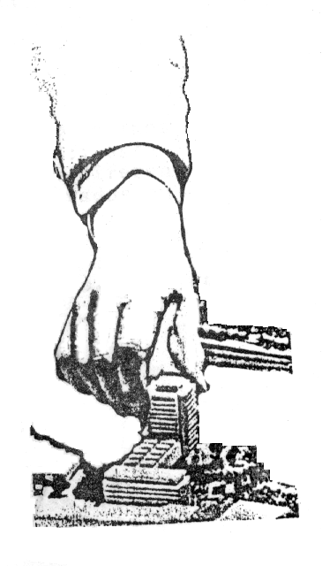

On his paper, this talented artist says:

“A three-dimensional space is sufficient for physical and physiological life of man; instead, his psychic life needs space subject to certain conditions in order to transform dead dimensionality into living speciality

Muñoz Soler to Lidia Orsi: During my “Workshop” experience, my impression was that young architects had suddenly gone beyond the drawing table until a corporeal choreography. Has this something to do with Gustavo Loiseau’s “resonance on the inner human space”, or with Barbuy’s “living speciality”?

Lidia Orsi: Yes, Gustavo Loiseau’s observations are perfect. Likewise we wondered, and reached a point in which our usual, differentiable and practical instruments were of no use to explore inner space and outer space; so we started a search by following other ways (which had to do with “that which one does not say”, with that which is “underlying”).
We believe this exploration on those other ways are not in charge of specialists, but also of all of us: we all possess files containing spaces lived and to be lived. That is to say, we could see new ways, which do not exist, which are about to be discovered.

Muñoz Soler to Lily Wencelblat. Again with University of Synthesis –and upon the basis of our Workshop experience here–, do you feel a search of this new didactic-pedagogic space could be made by a community of teachers and students who want to find a bridge between way of knowledge and way of life?

Lily Wencelblat: In my opinion, during this individualistic stage that we are travelling through, we reached a point in which we should stop and start our way, but with humbleness. In my view, this is the way.

Muñoz Soler to Liliana Llebaria: I believe that Liliana has a significant observation about “ecological dimension” of human space.

Liliana Llebaria: In my opinion, we should urgently include an ecological practice in the program of University of Synthesis, because a generation after us has to assume an ecological leadership in the planet. This task is too much strenuous, and we have to prepare it beforehand.
Up till now, individually we have worked detached from natural resources, as a strange thing handled by others, being unaware of what is our part in the formation of our environment.

Muñoz Soler to Lema Araujo: (A Professor at the Municipal Institute of Art Education, IMEPA, city of Avellaneda, Buenos Aires Province).
Last year, you offered us your experience as an educator by means of a lecture of deep human content and strong social sense:

“Education through art as human instrument and cultural identity”.

We ask the first question to Professor Lema Araujo.
In this book “Idea and Image”, Architect Louis Khan refers to art as follows:

“We teach art, but in general, we do not understand its basis
or existential function, and we reduce it to a pastime”.

In this sense, what is your experience as an educator?

Lema Araujo: Our reflection is as follows. Any “learning” process has ended with a tremendous confusion because we mistake apprenticeship for acquisition of knowledge and information, and for storage of this information.
It should not exist any contradiction between knowledge and apprenticeship because a human being is a whole and should function as a whole. But when this human being is absorbed by knowledge and information –through an exclusive mind training– eventually we consider that the acquisition of things is tremendously important, so we live in triviality and immediateness.

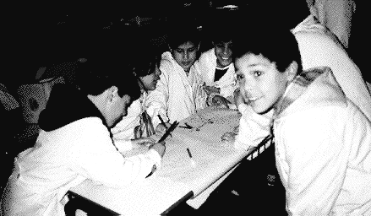

Muñoz Soler: Last year, during the course you referred to “cultural identity”.
What do you think of a possible integration of art and life for new generations in the frame of a “University of America”?

Lema Araujo: I repeat what I said last year. As Latin Americans, we are transforming education through art into something absolutely different from North Americans, Europeans and, of course, from the Asian and the African. We can discover –and here I point out this cultural identity– our eventual force shared with the rest of American countries, if we begin to look one another a little inward, –a kind of “implosion” (as we said during the Course), an implosion by an absolutely revolutionary transcendence.

Muñoz Soler: And now we will listen to

Elba Longhini, a psychopedagogue,
Mabel Negri de Cainzos, a Professor of musical education,
and they shall say something about their experience on the “Workshop of psychopedagogy”.
Elba Longhini: Our starting point was the pathological aspect, especially connected with children, and gradually we saw the need for working also with parents. So we implement a work with adults, not in connection with problems or recreational needs, but by opening new communication channels, by discovering a possible intimate and sensible expression, and by integrating the artistic expression into the pedagogic tool.

Muñoz Soler to Mabel Cainzos: Staring at University of Synthesis, how do you see a possible development of all these artistic forms with children and adults, eventually integrated with the body and life of young university students of the future?

Mabel Cainzos: In my opinion, on a new university project, the youths should experience all areas of education through art, by developing gradually and progressively latent possibilities in song, drama, plastics and music, and first by making personally their own instruments.

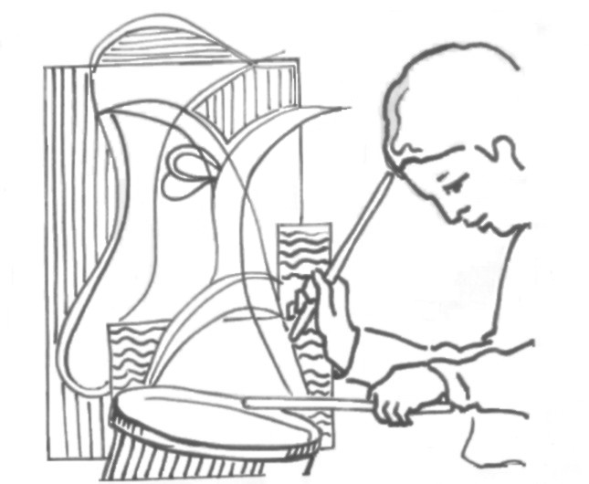

Muñoz Soler to Doctor Rubén Hallu: (A Professor on pharmacology, at the Veterinary Faculty, and a young teacher in direct touch with young university students of his time.)

Rubén, during the Course of this year, you recognised the importance of this level of human development connected with the age to be admitted by the University, 16-18 years old. I named this evolutionary stage of a young student “critical fluctuation area”, in which life is not crystallised in a form yet. There one can start something new. If we introduce schematically the educational process as a current circulating through the “tree of knowledge”, and we mark this year 1988 as the school starting point for a 6 year old child, this child will reach his admittance age for the University by 2000, and find himself on this “area” of the tree in which its branches begin to come apart.
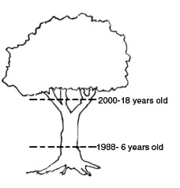

Epilogue

Before the collapse of a culture that has emphasised the possession of material goods, sooner or later, somewhere in the planet, we must start everything anew.

Educators of tomorrow must teach the present-day children to cross the cosmic barrier. But a question may be proper: where these teachers are formed?
–There are multiple institutes for different levels of teaching (pedagogic baccalaureates, faculties of sciences of education, secondary professorships, and kindergarten professors, and the university teaching career), but the unity of the “mastership” and the universal meaning of the education are lost. Today we have more technicians and professionals, but less teachers.

At present, educators are substituted for therapists. It is a sign of our time. The point is that we are ill.

The new University must be in charge of forming teachers in order to teach the new generations to cross the dangerous threshold between physiology of terrestrial man and physico-ecology of cosmic man.

A utopian proposal?

Yes, as utopian as wishing to put on orbit a “space telescope” 3 billion dollar worth to see the Universe closer!
But, the “Hubble” project in on the way, with 500 different ways of operation, one 94 inch mirror, one computer set to register readings by 16 observatories in different areas of the world, with a staff of 250 technicians, which includes 60 astronomers.

University of Synthesis is something similar. A human antenna placed somewhere in the planet to receive not only messages from the sky, but also messages coming from Earth.

Where in the world a genetic convergence of human, telluric and cosmic forces can take place to bring into action the expansion of consciousness in coming men and women?

–I feel this place is America.

If on planetary scale today we can place on the United Nations University in Tokyo, Japan, the expansive pole of scientific-technical knowledge, the pole of “human implosion” has to be in America.

Why America?

–Because America, the “deep America” (in Rodolfo Kusch’s words) has reached, in the soul of its peoples, a sufficient level of interiority to offer, to the emerging “globalisation”, a “human bridge” between celestial archetypes and wisdom of Earth.

On a potential American new man we begin to glimpse the first traits of material and spiritual values in tune. Without this pole of human interiority ‘dissolving’ those compounds of dehumanisation produced by a technical civilisation, “transcendent technologies” (as Thomas Berry calls them) may lead us to a new collapse of Atlantis, the post-modern Atlantis.

