2nd Part

University of Synthesis

Educational pattern for the planetary civilisation
of the third millennium

A dialogue with members of the team

Muñoz Soler: The first question to the Professor of physico-chemistry at La Plata University, Argentina, and a researcher on quantum physics, Doctor Eduardo Alberto Castro.

e־
e־

B
A
e־
γ

e־

During the course of past year, Doctor Castro was in charge of the following subject:

“Some reflections about quantum physics and expansion of consciousness”.

His lecture focussed a methodological criticism about present-day unifying proposals among disciplines belonging to different areas. In connection with a possible relationship between science and mystique, he said:

“Recently multiple papers from physicists, philosophers, psychologists, theologians, et cetera, have appeared with the purpose of discovering and explaining the extraordinary and revelatory relationship between modern physics (the hardest science) and mystique (the more tender religion).
In my view, modern physics does not offer any positive supports, and much less definite and decisive proofs for a mystical and spiritual vision of the world. But great physicists of the beginning of century were mystics”.

Now we will not continue the polemics derived from Doctor Castro’s words, a polemics that, on one side, remains on a scientific and philosophic field. But, my question is as follows: Do not you feel that, with this discussion connected with the “holographic paradigm”, we run the risk of substituting the ancient theological debate for a modern epistemological polemics? May not be better to “work together” in order to discover this new field of creativity which we could name “human hologram”?

E. Castro: My answer is yes, but I want to point out that, if these two fields (science and mystique) aim at the same end, they work with very different methodologies. On the other side, I feel proper to warn about early syntheses and arbitrary extrapolations.

Muñoz Soler to Eva Sarka (Professor on Superior Education and former Coordinator in Department of Informatics and Educational Investigation, National Bureau of Superior Education (Ministry of Education):
During the course of the past year, Eva was in charge of the following subject:

“Human Communication and Systemic Pedagogy”.

I select a paragraph from her lecture:

“Today we can entirely accede any information. I can read the “British Encyclopaedia” on a CD in a disk drive.
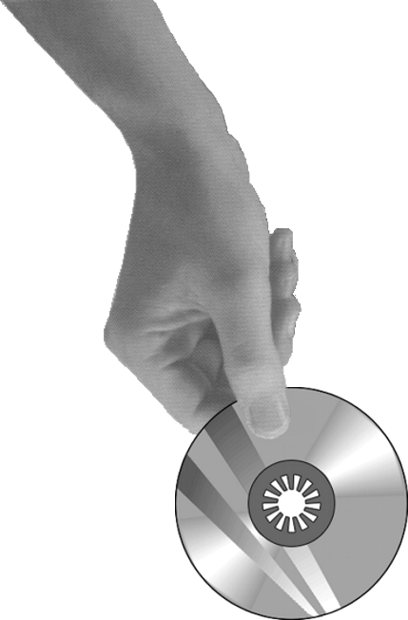

On the other side, I can simultaneously communicate through a MODEM –as short time ago we did– with students in Buenos Aires, Bariloche, Mar del Plata and the United States. There we found children “chatting” with their companions from other areas of the world.”

Muñoz Soler: My question to Eva is as follows:
Throughout the times, the biological evolution has been transferring tools incorporated into the body and technical instruments outside the body (by substituting a digger-leg for a power shovel).
After an integration of its different departments and workshops by means of electronic satellite circuits, cannot the University of Synthesis constitute a pole of “implosion of knowledge-and-expansion of consciousness?”

Eva Sarka: In my opinion, if we rescue the original sense of education and create a dynamic communication on a new space, without inside or outside, but with “something” synthesising the communication inward-outward process, the store of a “mass” of information about tools of human creativity may co-operate so that this “flow” is not broken and may emerge a new creative synthesis.

Muñoz Soler to Ricardo Bulrich (an Architect and Professor on the Basic Cycle, Buenos Aires National University).

His subject during the course of past year:

“Projection as an instrument of change”

Ricardo referred to the “human habitat”, not only to the physical aspect, but also to the entire system of relationships in which a human being develops his living. And he pointed out utopian patterns in connection with the formation of this “habitat”.

“Utopian patterns”, Ricardo said, “ever had, though in some chimerical way, a revolutionary function. Buckminster Fuller (famous for his geodesic domes) follows this utopian tradition. He imagines a revolution, a change, promoted by a projection”.

Ricardo was not very optimistic in relation to certain possibilities of repairing those damages of man against the ecological environment of the planet and against his own habitat, since in his opinion there are irreparable damages (time-bombs in our environment threatening the future life), but he does not declare himself either totally pessimistic, and even poses his proposal of a “constructive pessimism”.

“In front of a possible self-destruction of the human species by “irresponsible” growth, let us counteract it by means of “responsible growth”.

Muñoz Soler: Ricardo, from the viewpoint of an utopian pattern, could not the University of Synthesis have a revolutionary presence in our current world in terms of its own architectonic language? How do you intuit the new “university habitat”?

Ricardo Bulrich: Regarding to the pattern of University of Synthesis, I wondered several times where could this University be definitely placed, and how could we lecture in our familiar context. I could hardly imagine this University in a city. It is difficult to reconcile a new educational space of synthesis with the pollution of present-day cities. In this sense I remind the Amancio Williams’ idea, which is an “Utopia”. He thought of a linear city, which on its transversal cut could be a short distance between nature and downtown.
If we think of University of Synthesis, it should be inserted in a scheme enabling man to remain somehow in the centre of nature and hardly establishing a spinal communication, as it were, with the entire urban process.

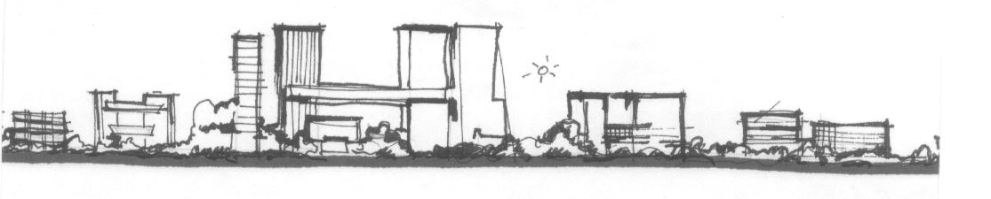

Muñoz Soler to Gustavo Loiseau (an Architectand organic architecture researcher):

Last year, the subject of Gustavo during the Course was as follows:

“Organic architecture as an answer to the awakening
of consciousness in planetary man”.

Gustavo began to tell:

“At present, our attempt is to come rapidly closer to this idea: how different stages of human consciousness, on their different times of development, can be observed on remaining buildings of those times.”

And his lecture continues with a short compared report about architectonic design and expansion of consciousness.

“In the young India, we witness the appearance of “semi-spheres”, which imitate the sky, but being the latter separate from Earth.
In North Ireland and France, “Celtic dolmens” are just points of reference playing with the incidence of the light on them and with their projections of shadows.
In Persians buildings we witness certain light-darkness opposition, as a symbol of tension manifested by a cosmogonical dualism.
Among the Egyptians, we can see with clarity the “mass”, massive pyramids, and passages as a metaphor of penetration into matter.
The Greek made a 180º turn in the Egyptian temple. There, pillars are outside, and the stress is on the space that separates one another; with an altar in the centre, but none enters this temple.
The Romans built bridges and aqueducts as symbols of conquest of the world and circulation of life.
And the Medieval soul rises to the sky through needles of Gothic cathedrals.”

Muñoz Soler: My reflection related to Gustavo’ work is as follows:
We have seen architectonic remains of extinct cultures, as frozen images on the time of their respective cosmic visions. And at present we see buildings of modern technique which, as Octavio Paz properly says, “are symbols of action, but not images of the world”.

My question to Gustavo is this:
“Is it possible to intuit the architectonic form of the incipient awakening of a cosmic consciousness in humanity of our time?

In this sense, we should stress the human/cosmic symbolism of Gyula Kosice’s work, presented at the “International Sculpture Display in the Open”, during the Seoul Olympic Games, by 1988.

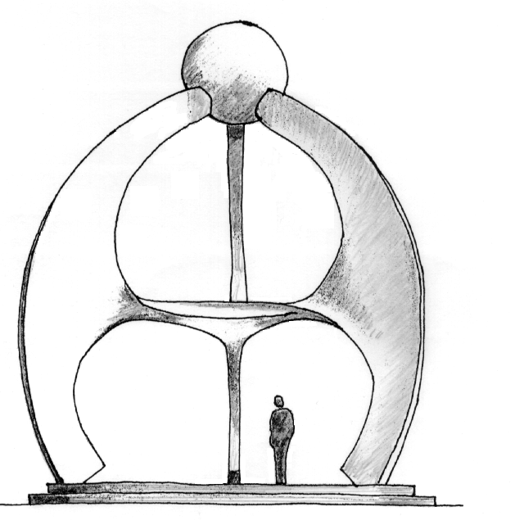

Gustavo Loiseau: I do not know if at present we are in a position to find a form. But of course we can say cosmic space is “resounding” on inner human space, and in this sense there is indeed a way of inward searching. If we look inward we may find certain space in which this new form could take place.

