Pedagogy of Synthesis

The following are the most general principles of this co-evolutionary pedagogy:

Principle of  anteriority | It is a pedagogy of before:  before a fall in fragmented knowledge;  before any professional distortion by a unilateral development of functions;  before life may crystallise in a form.
Principle of  creativity | Creating conditions for the expansion of consciousness and release of human energy.
Principle of  interiority | It is a principle of self-consciousness, of reversibility of values: making inside what one wants to make outside.

Methodology of Synthesis

Here “method” is “educational method”. As McLuhan would say, “medium is message”.

Not only information circulating through the tree of knowledge,
but also sap flowing through the tree of life.

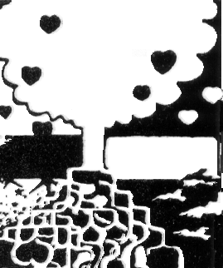

This “pedagogic medium” is configured by

logo-technical circuits of resonance.

What are “logo-technical circuits”?

–“Organic matrices” through which the sap of life is circulating. “Human medium” to live, grow and be.

If for one reason or another, one cannot contact in a direct way these “primordial mothers”, then life dries up, grows weaker, and declines.
What are these “first circuits” that configure the invisible geometry on the University of Synthesis?

The first circuit is of
human resonance

It is the first law (“may brothers be united”, as Martín Fierro says).
University residence is its practical instrument. Here one learns how to live together.

The second circuit is of
cosmic resonance

Here one learns to come into direct contact with the cosmic consciousness/energy.
Practical ecology is its tool.

The third circuit is of

Expansive/implosion of knowledge

Here one learns how transform ‘matter’ of knowledge into expansion of consciousness and release of energy.
Circuits of computerised information and workshops of creativity are its tools.

The fourth circuit is of
spiritual resonance

Here one learns how to understand by participation. Social consciousness of a “student apprentice”. Social work is the tool.

The fifth circuit is of
spiritual resonance

It is activated by reversibility of values and spiritual transcendence.

How to differentiate methodologically a technical circuit from a logo-technical circuit?

–On a technical circuit, knowledge of the art rules are sufficient, and the result will be correct. It does not matter if it is the right or wrong person.

–On a logo-technical circuit, a different law is in force. Here the Chinese aphorism is valid:

“Right method with wrong person: wrong result”
.
“Wrong method with right person: right result”.

Not all ‘human cells” integrating these logo-technical circuits stay on the same geographic place or on the same coordinate of time, in the way of our familiar technical teams, but configure a visible and invisible web of operators with differenti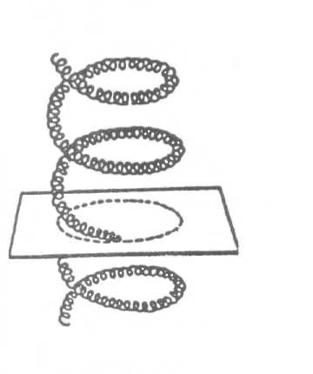al functions, but all of them united by the same vocation and the same meaning of the work.

Resonance by similarity on a space of
Different curvature.

C. Bragdon

Our experience on the “Workshop of Synthesis” has made us see how this “resonance by similarity of differential functions” is not easy to achieve at all. And the division between different areas of science, philosophy, art and technique is even stronger, and above all, the isolation among different researchers is more stressed. Academic prestige, economic interests, ideological positions, and eagerness for power are also barriers to reach this ‘critical point’ of human meeting in which understanding becomes expansion of consciousness and solidary participation in the work.

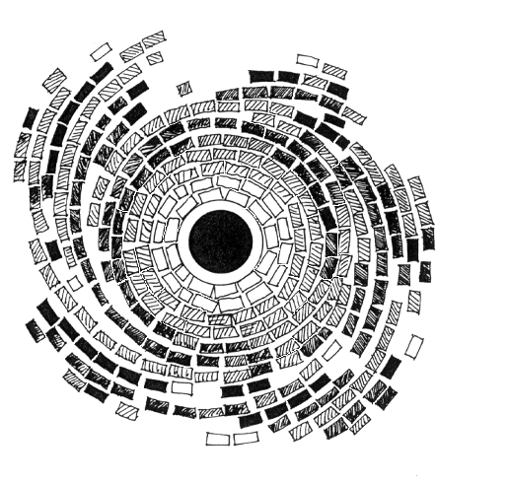

Epilogue

Before the collapse of a culture that has emphasised the possession of material goods, sooner or later, somewhere in the planet, we must start everything anew.

Educators of tomorrow must teach the present-day children to cross the cosmic barrier. But a question may be proper: where these teachers are formed?
–There are multiple institutes for different levels of teaching (pedagogic baccalaureates, faculties of sciences of education, secondary professorships, and kindergarten professors, and the university teaching career), but the unity of the “mastership” and the universal meaning of the education are lost. Today we have more technicians and professionals, but less teachers.

At present, educators are substituted for therapists. It is a sign of our time. The point is that we are ill.

The new University must be in charge of the formation of teachers in order to teach the new generations to cross the dangerous threshold between physiology of terrestrial man and physio-ecology of cosmic man.

A utopian proposal?

Yes, as utopian as wishing to put on orbit a “space telescope” 3 billion dollar worth to see the Universe closer!
But, the “Hubble” project in on the way, with 500 different ways of operation, one 94 inch mirror, one computer set to register readings by 16 observatories in different areas of the world, with a staff of 250 technicians, which includes 60 astronomers.

University of Synthesis is something similar. A human antenna placed somewhere in the planet to receive not only messages from the sky, but also messages coming from Earth.

Where in the world a genetic convergence of human, telluric and cosmic forces can take place to bring into action the expansion of consciousness in coming men and women?

–I feel this place is America.

If on planetary scale today we can place on the University of the United Nations in Tokyo, Japan, the expansive pole of scientific-technical knowledge, the pole of “human implosion” has to be in America.

Why America?

–Because America, the “deep America” (in Rodolfo Kusch’s words) has reached, in the soul of its peoples, a sufficient level of interiority to offer, to the emerging “globalisation”, a “human bridge” between celestial archetypes and wisdom of Earth.

On a potential American new man we begin to glimpse the first traits of material and spiritual values in tune. Without this pole of human interiority ‘dissolving’ those compounds of dehumanisation produced by our technical civilisation, “transcendent technologies” (as Thomas Berry calls them) may lead us to a new collapse of Atlantis, the post-modern Atlantis.

