The cosmic man is born

He reveals himself He hides
like an event like a form

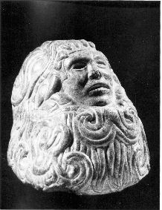

Ancient myths
have given a face to the Plumed Serpent,
but the spacesuit of the astronaut
is just a prelude to a body of fire.

Or the advent of the new

Nicodemus’ question:
“How can a man be born when he is old?, can he enter the second time his mother’s womb, and be born?”

Physiochemistry and biology do not give the answer, but help us to understand: in unstable systems, in critical points far away from balance, eventually an enlarged fluctuation can break symmetry and give rise to entirely new structures (Prigogine).

In the world there is something new.
The cosmic man is born.
We need a science to explain it.

Two ways

in Chartres Labyrinth

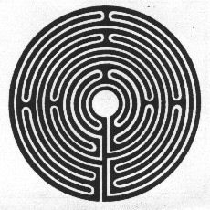

Two currents Double helix
in Jacob’s scale. in DNA molecule.

SYNTHESIS

The unified field formula between knowledge and Life does not come through the way of science but through the way of man,

because unity of man is before unity of science.

The Heart of man can establish again the bridge between laws of time and mystery of eternity.

It is a new rhythm,
a new Synthesis.

The word synthesis is equivocal as a concept, but fertile as a symbol.

Trans-finite function of a human heart, which starts producing fusion energy.

Reversibility of values.

Arkhi-techtonic Design

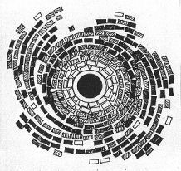

NEW UNIVERSITY MASTERSHIP

Sooner or later,
somewhere on Earth,
we should start all anew.

The point is not to convey information (informatics webs tend to it) but to assure circulation of goods of life (so that human energy may not decline:

trans-mission of a new Mastership.

Pedagogy of Synthesis

A professional and technical University has answers to knowledge and power, but does not to man.

We start discovering how the trans-mission of cosmic energy / consciousness is made by “human operators of synthesis”. They are educators of the future, catalytic agents in a Gen-ethics of trans-finite functions. They introduce not only a synthesis as a methodological tool, but also they are synthesis by themselves.

What is pedagogy of synthesis?

Pedagogy of “before”;

before a fall in fragmented knowledge,

before a professional distortion by specialised functions:

before life crystallised in a form.

Before depositing information,
they open the way to vision.

Principles, Functions and Tools of a New Message.

Realising inside what one wishes to make outside.

Human con-stellation of cosmic functions.

Trans-mission of social goods.

Human hologram

Key words in science of today:
evolution, information, irreversibility,

only a “half of the formula”;

the “other half” is: revelation, transcendence,
reversibility of values.

Beyond chemical clocks and cosmic pulsars, the alternate pulse of an ‘Atomic Heart’ is beating.
The soundless word of this heavenly Messenger has been replaced by materialistic rationalism and idealistic spiritualism.

But today,
between twilight of ancient gods
and birth of a new Sun,

a powerful current of knowledge runs in
the scene of history and calls all together
to a new dance of life.

University of Synthesis?

It is hard to find the proper word.

It is an Idea-symbol.
More than an institutional form
it is an energ-ethical wave charged with sense,
an intelligent force of the Message configuring
a new Gen-ethical code with human matter.

