Ramón P. Muñoz Soler

UNIVERSITY OF SYNTHESIS

Steps to Gen-ethics
of human trans-finite functions

Excerpt from
Universidad de Síntesis. Pasos hacia una Gen-ética
de funciones humanas trans-finitas

Translation by Héctor V. Morel

Steps to gen-ethics of human trans-finite functions

Sign of our time:

existential crisis,
loss of image in the world

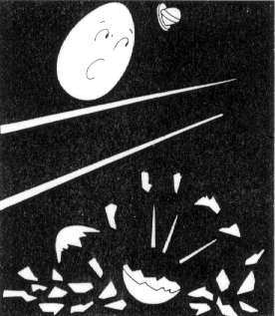
LOST UNITY

Symmetry break.
Irreversible fall.
Initial conditions forgotten. Concealment of being.

“Neither knights of the king,
nor men of the king
were able to assemble
Humpty Dumpty again.”

But, what about the King?

It is the end of history?, or the end of a story?

Crisis of foundation,

where to rest one’s head?

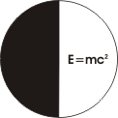
A FRONTIER HARD TO CROSS

Einstein revealed us a unknown
world, but only gave us

“a half of the formula”.

In equation relativity,
values of man,
time of life,
history of the universe
are left.

Later other names and other formulas would come

Planck ħ = 6,77 x 10²⁷ (action quantum)

De Broglie ħ (pilot waves)

λ =
mv

Heisenberg pq = qp (uncertainty principle)

Schrödinger Ĥφ = Eφ (wave equation)

Dirac +m = -m (anti-particle physics)

Boltzmann S = k log P (entropy production)

Prigogine (self-organizing)

But again and again, the long-awaited unified field equation is beyond our reach.

Anyway, now in the threshold of the twenty-first century,

what is our greatest conquest for the progress of science and technique?

–Today, to have attained by ourselves the farthest reaches of both philosophic and scientific knowledge.

A frontier that is hard to cross!

And now, what?

