RAMÓN P. MUÑOZ SOLER

GERMS OF FUTURE

IN MAN

PLANETARY CIVILISATION

OF

THIRD MILLENNIUM

TV 7 Channel interview, Mendoza, Argentina.
October 10th 1986

Excerpt from
Gérmenes de Futuro en el Hombre
-Civilización Planetaria del Tercer Milenio-
Entrevista televisiva por Canal 7 TV Mendoza
10 de Octubre, 1986

Translation by Héctor V. Morel

GERMS OF FUTURE IN MAN

AND

PLANETARY CIVILIZATIONOF THIRD MILLENNIUM

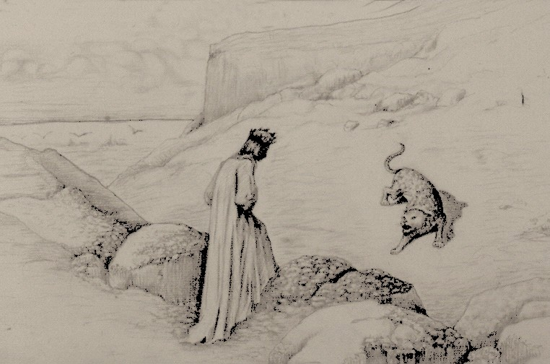

“A te convien un altro viaggio”

1986

TV 7 Channel interview, Mendoza, Argentina. October 10th 1986

Presentation

The gentleman here present is Dr. Ramón P. Muñoz Soler, a doctor and researcher into sciences of man and “Subjects of Future”. As an author, he wrote, “Germs of Future in Man”, “Way to Egoencia”, “Anthropology of Synthesis” and “University of Synthesis”, (“Gérmenes de Futuro en el Hombre”, “El Camino de la Egoencia”, “Antropología de Síntesis” y “Universidad de Síntesis”) among other books. His paper in “Anthropology of Synthesis-Egoencia of Being” has been read at the First Latin-American Congress of Medical Psychology and Psychotherapy”, held in this city. Now we should like to ask Dr. Muñoz Soler some questions about the future man and planetary civilization of third millennium.

Question:
Dr. Muñoz Soler, you talk about “future man”, “planetary man”. As a matter of fact, is there a “new man”, a human being on Earth, who belongs to the future?

Dr. Muñoz Soler:
I talk about “germs of future in man”.

Question:
Why do you say “germs”?

Dr. Muñoz Soler:
Because we are in the presence of something “germinative”.

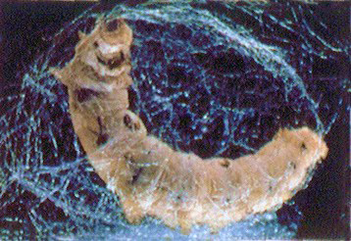
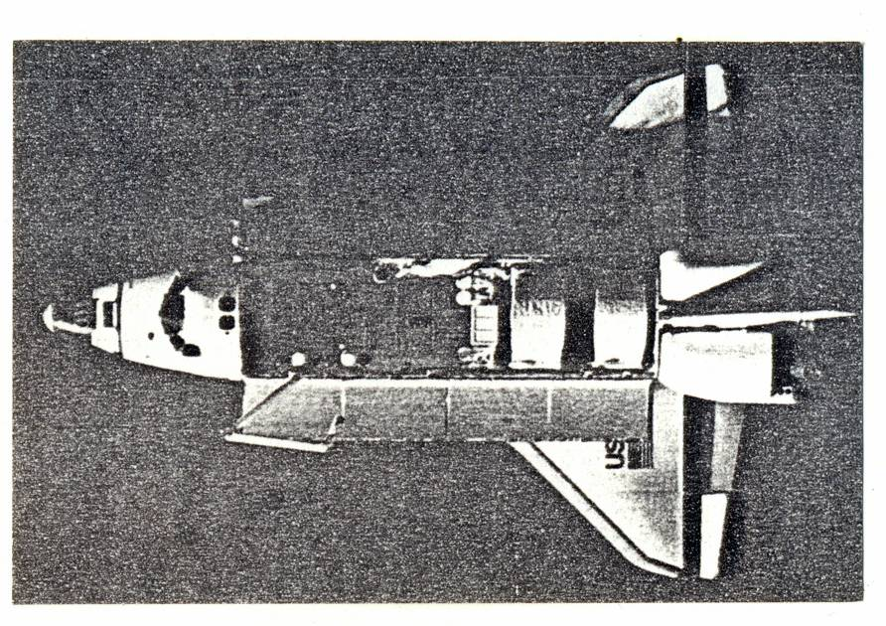

As much in nature as in man, most important transformations of life are made in a “capsule of interiority”. It is there that a germ of the new is born.

Question:
What are these transformations in present man?

Dr. Muñoz Soler:

Changes as to mind, sensibility, and even structure of molecular biology.

Question:
But may one speak of luminous future? Many people feel that there are clear signs of lost values, and the future threatened with catastrophes of any type.

Dr. Muñoz Soler:
But apparently, when everything is in disorder outside on the social mass, a primordial germ of new man already throbs in the deep waters of life.

Question:
Is there any link between the techno-scientific revolution in contemporary world and the above-mentioned transformations?

Dr. Muñoz Soler:

Certainly, what we see on the outside –planetary communication network, space race– is just the outer face of what occurs in the “inner space” of man.

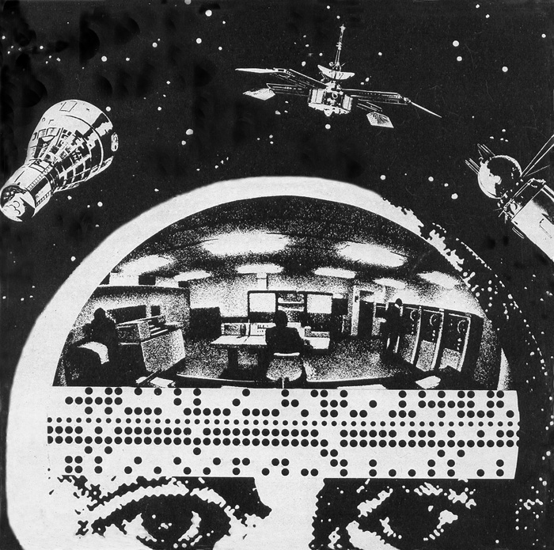

For an “electronic brain” on the outside, an “atomic heart” inside.

Question:
In general, when we speak of the future, we emphasize informatics, genetic engineering, or “galaxy war”, but saying little or nothing about these changes occurred deep inside a human being.

Dr. Muñoz Soler:
Yes, we still don’t know how to decipher the “message as a whole” in the new sign of time.

Question:
Where the trouble is?

Dr. Muñoz Soler:
An “eye” is lacking. Too much information, but a “vision” is wanting.

Question:
But, anyway, as matter of fact, is there a “message coming from the future”?

Dr. Muñoz Soler:
Yes, it does, but our trouble is to recognize it.

Question:
Why are we unable to recognize it?

Dr. Muñoz Soler:
Because we look for it where it is not. We look for an “ideological content” of the message, instead of being ourselves in tune with the message itself. The post-modern message is not ideological, but vibrational. Thence one’s trouble to recognize it.

Question:
Why do you say “vibrational”?

Dr. Muñoz Soler:
Because it is an “invisible light”. You suffer from it, you endure it, previous to recognizing it.

Question:
One cannot easily understand what do you mean by “invisible light”.

Dr. Muñoz Soler:
It is something like what you see on this fog camera, when certain high power photon collides with an atomic particle and divides matter from antimatter. You see an effect of this collision (matter turning in one direction, and antimatter turning in another direction), but the camera eye is unable to detect a “penetrating ray”.

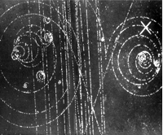

Question:
Also is the world of man divided off?

Dr. Muñoz Soler:
There was a shift on its stability condition. Since 1945 we are not so sure any more.

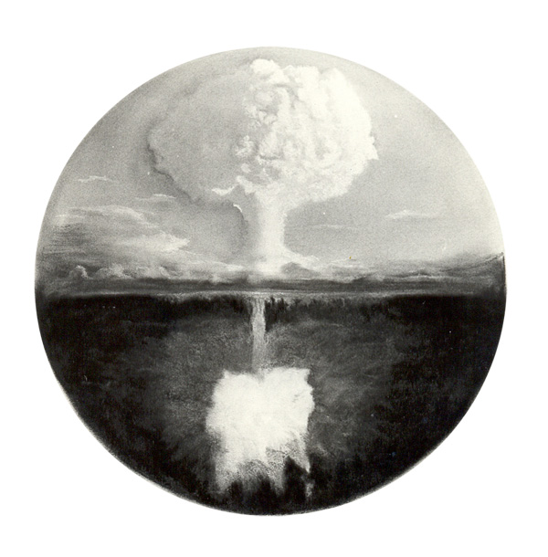

Now we stay in a house with no support. The “material support” of human existence is broken.

Question:
In your opinion, does the first atomic blast mean the beginning of a new age?

Dr. Muñoz Soler:
It is a “paradigmatic initiation event”.

It is a “symmetry break” in the old system, a rampart knocked down, a gate open, a light getting in. We don’t live in the same world any longer, we don’t speak the same language any more.

Question:
You speak of “entry of light”. But, forty years after the atomic blast, we did not see a rampant terrorism on the world level, juvenile crime, planetary pollution, and social outburst of any type?

Dr. Muñoz Soler:

It is the “dark face” of this phenomenon, its “implosive” face. When light gets in, the “shadow power” is exposed. Double face of the one and only luminous and dark event at the same time.

Question:
Today many people have a feeling of “being on the air”, “having lost their bearings”, or “not knowing who is who”. Does this have something to do with breaking the cosmic barrier?

Dr. Muñoz Soler:
It does, suddenly we have entered in a new space,

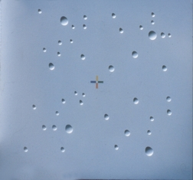

Magariños D.

but we still don’t know how to sail this space.

Question:
Today do we have any guiding science?

Dr. Muñoz Soler:

In my opinion, NO. Present science only gives us “a half of the formula”.

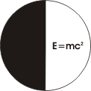

Question:
Why do you say “a half”?

Dr. Muñoz Soler:
Because of our fragmented knowledge, which is only fit for practical purposes, but insufficient to fill up the sense of existence. On the outside we are going to conquer remote stars, but inside, we end in existential anguish and loss of sense.

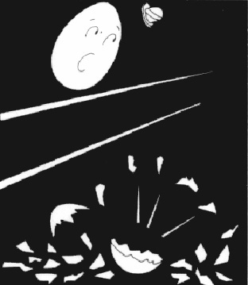
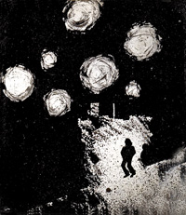

Question:
In your view, don’t you feel that we need a new philosophy of values?

Dr. Muñoz Soler:
In my opinion, one may have a new philosophy of values, a new philosophy of science, a new political philosophy, or a new philosophy of religion, and we can go on to be old men.

Question:
How so?

Dr. Muñoz Soler:
So, when one understands that the way of knowledge moves away from the way of life, we need a “new journey”, not a new philosophy.

Question:
A new journey?

Dr. Muñoz Soler:
Yes indeed, when Dante confronts the wild beast blocking his way, he listens to Virgil’s voice saying, “A te convien un altro viaggio”.

Question:
Other journey?, of what kind?

Dr. Muñoz Soler:
It is a way inside, “going up the waters”, as Leopoldo Marechal would say, a 180º turn in the direction of force. Here is the main challenge.

Question:
And how to respond to this challenge?

Dr. Muñoz Soler:
At present, there are partial and unilateral responses.
The “logotechnical” man, who can tread on remote planets, is unable to solve serious troubles caused by starvation, unemployment and degraded life, which we see as they emerge with heart-breaking harshness.

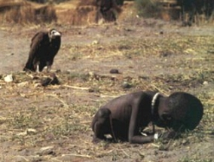

Question:
So, where is this response coming from?

Dr. Muñoz Soler:

Not from Academies; this response comes from the wilderness, from a “wilderness trial”.

Question:
What is this so-called wilderness trial?

Dr. Muñoz Soler:

Moving across one’s shadow.

It is the extreme experience of millions of men and women moving today across the wilderness of modern civilization. A stone heart can be open and a human soul can contact the light under extreme conditions of social pressure, existential void and spiritual temperature. Many persons remain behind on the way, but some of them come back and have a new state of consciousness.

Question:

At any rate, would this be within the reach of very few? Would we not be in the frame of an individualistic elite message, with no answer to big human masses claiming for social justice and better conditions of life for everybody?

Dr. Muñoz Soler:
I don’t speak of elitism, individualism, or socialism. I speak of “egoencia of Being”.

Question:

What is egoencia?

Dr. Muñoz Soler:

It is a word-symbol to name “transcendental/individuality”. It is “operative presence of Being”, reversibility of values.

Question:

How does this individuality of egoencia work on a process of change in our present society”?

Dr. Muñoz Soler:

It works as a “pole of interiority”, which balances inside an expansive dynamics of technical society. As we said in the beginning, for an “electronic brain” on the outside, an “atomic heart” inside.

Question
In your view, what is this so-called atomic heart?

Dr. Muñoz Soler:
It is a lost function. We stay only with a mechanical heart. An “atomic heart” is a transcendental organ of feeling, a “fusion reactor”, where soul values are united with life chemistry under high temperatures of the spirit.

Question:
New values of the future man?

Dr. Muñoz Soler:
Yes indeed, but not only abstract values, but even “substance/values, indispensable ultra-elements to developing life. Under a fatal loss of these “imponderable ingredients”, a civilization can collapse as a whole. Now we begin to undergo the first symptoms. Today we are suffering from true social diseases by lack of “substance/values”, just as in the past we underwent plague and diseases by lack of vitamins. By lack of spiritual light incorporated into matter, a person demeans and descends into the world of shadows (by lack of light), and a society falls ill (by lack of sense).

Question:
Can one recover the sense of values?

Dr. Muñoz Soler:

In my opinion, yes indeed, but still we are quite blind to these things. We have lost our sense of belonging to the social body (alternating body). We don’t understand that “someone else” has to pay the evolution price. If we go on to consume more power than that that we produce, someone else has to consume less and to pay more. And if we don’t take part co-evolutionarily with our own values, with our own possessions and with our own sacrifice, then, watching TV screens, we’ll go on to witness the most cruel spectacle forced by our modern civilization: daily sacrifice of the innocent.

Question:
Do you are proclaiming a new ideal to sustaining life?

Dr. Muñoz Soler:

I rather would say, a new life to sustaining the ideal! Up to yesterday I felt that an ideal to sustaining life was enough. Now I understand that we need life to sustaining this ideal. If we don’t bring higher human functions into action, if we don’t enter the new world on time, and if a new Earth doesn’t standup, then insects –insects that we carry inside– will invade us (they are invading us even now).



“toda teoría es gris, amigo
y verde el árbol de la vida”

