Organic Architecture as a Response to the Awakening of Consciousness in Planetary Man

Gustavo Loiseau

“Inhabiting is human. Wild animals have nests and dens, stables for cattle, sheds for carts, garages for cars. Only human beings can inhabit...”
Ivan Illich

What we are going to do here is to approach rapidly an idea about how different stages of consciousness of humanity –in their different times of development– may be observed on buildings of those times that still remain.
So we see in the young India how semi-spheres emerge that imitate in a parallel way what is heavenly. They emphasise it, by suspending and separating the surface of Earth, by way of palms of hands upward.

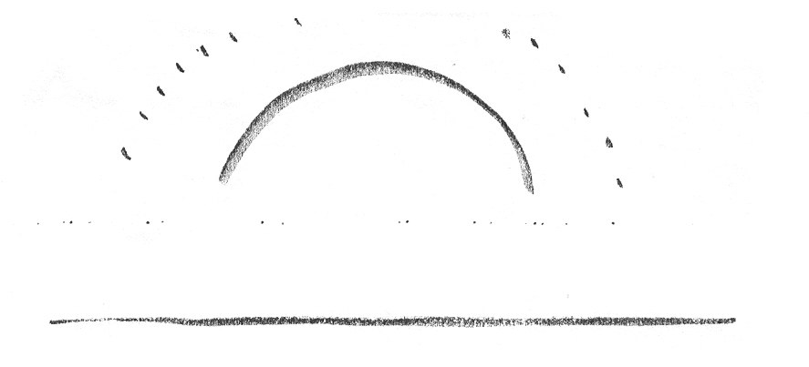

In Ireland and North of France, Celts erect their dolmens and menhirs nailed in the earthly surface, but the limits of their temple has the same heavenly dome upwards and an immense horizon by its sides. Here the relation with the cosmos is direct, here there is no matter intervening, as in India. These huge stones are only reference points playing with the light and shadows projected. So these strenuous Celts had their Heaven to reach being young.

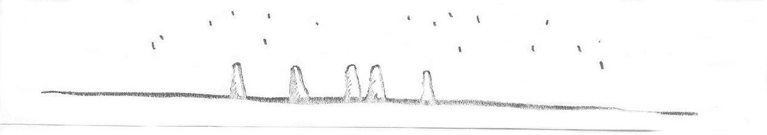

Persians implore Mazdao when they pray:

“listen to us, you live in the Divine truth and joy,
put an end to falseness and give us support
when the evil and low overwhelms us.
Lead your joy, your light
to our dark sadness.”

Harmony does not exist any more among Persians. There is tension and conflict between light and darkness, between good and evil. All this could be under control by means of their spiritual force. Zarathustra fought this way. And on this struggle, Earth only yields fruits to those who work hard. Here the first farmers are born.
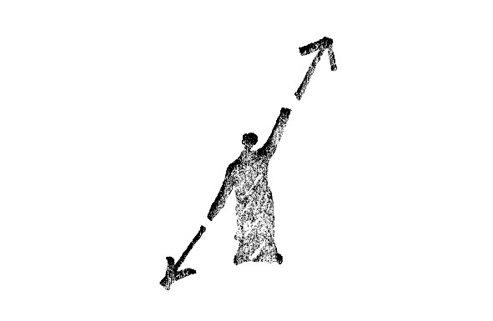

On the crossing of rays toward the cosmic constellation, massive blocks take birth as a radial counter figure. Now the mass comes up. From the outer space, corridors and doors grow smaller in this painful duty of entering the mass, in this hard toil to enter the earth. Here is wisdom and peace that we had not with Celts. Sunk in the huge mass, we have initiation chambers, corridors, and pillars

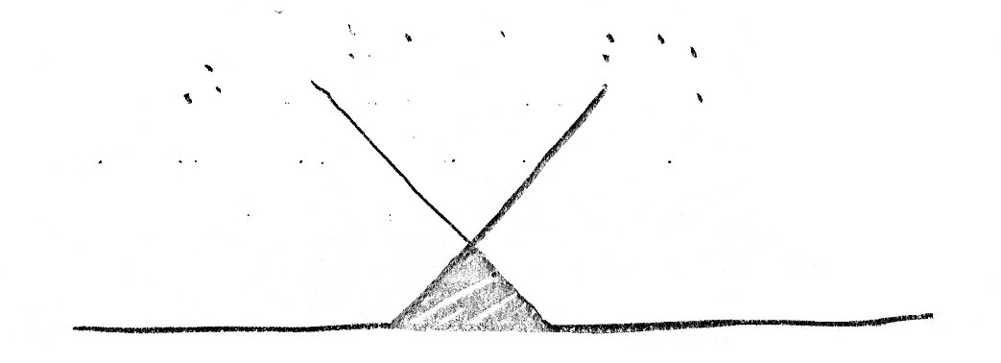

The Greek man changed completely the Egyptian temple: now we find pillars outside, and the altar is the only material thing that remains inside. You must not enter this temple. As we were Greeks, we felt happy on Earth, and willing to use properly this life. There is a play of lights; sun and shadows display grooves on the pillars, there is balance and harmony.
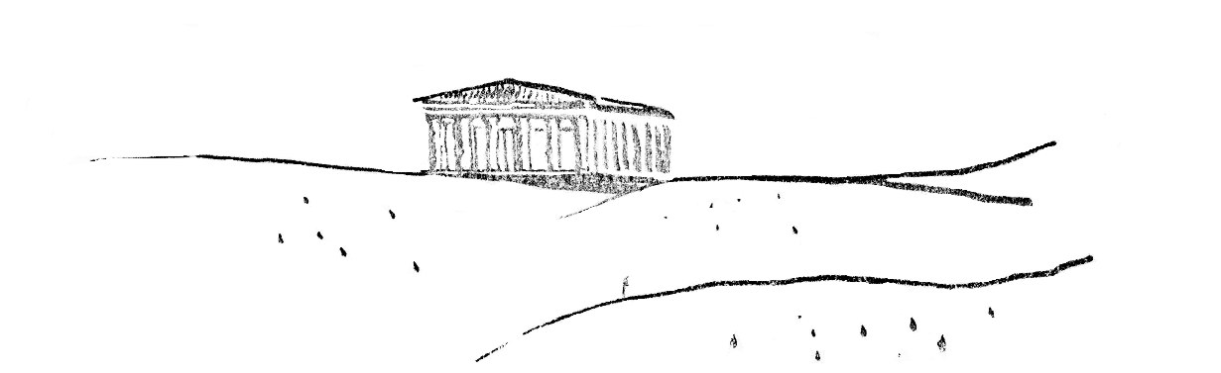

Romans had already matter under control. Engineers built bridges and aqueducts. An Arch has been built, but now it the SELF, the incarnate ego who crosses this gate. And at the same time the beginning of something new comes up: the Christ enters the Gate of Jerusalem.
Henceforward, with this new consciousness, buildings are gradually manifested. I am inside. The Egyptian struggle for “I must enter” is over.
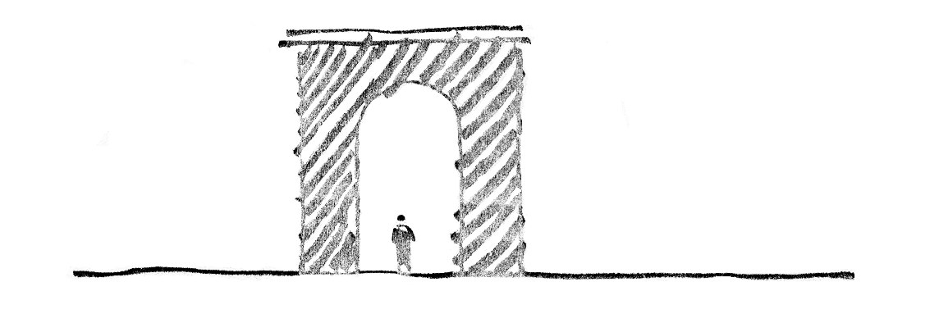

In this search, with this inner force, a community rises in Gothic cathedrals.
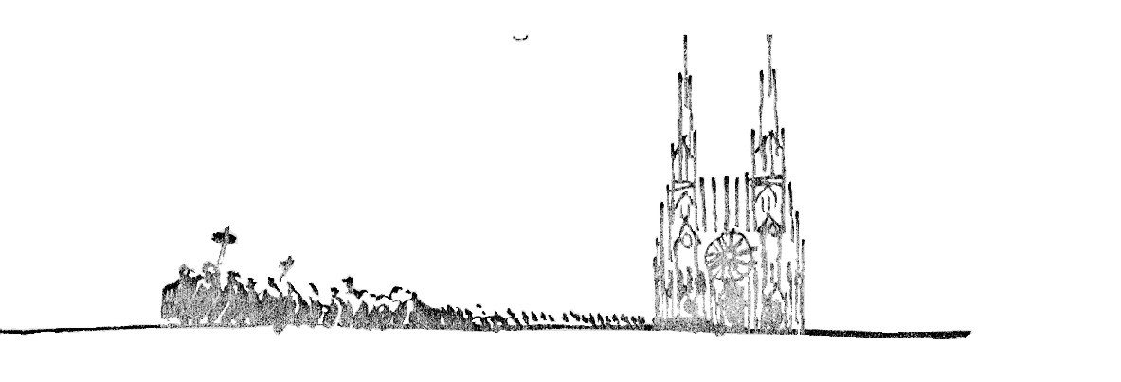

It is this ENTERING that forerunners, artists, architects show to humanity. Here is their duty, to show “this is what you are living now”. And here is the responsibility of an architect today: as a forerunner, to try an interpretation of the present consciousness, and to show the way.
Fragmentation of knowledge –a result of analytical methodologies used by natural sciences have– has prevented us from crossing the rampart that our culture faces today. The new body that we need may be born of new sciences of the spirit and of understanding the state of consciousness of the present man. It is there that architects, artists, educators, peasants, are studying phenomena from the new point of view, in order to know formative forces, their laws of metamorphosis, along with some sorts of geometry leading these processes and their understanding to planes of consciousness. A geometry as development of thinking, by making the passage from forms in motion to static forms conscious.
Let us think about Palaeolithic caves: the most ancient attempts of man to keep, by way of images, his experiences in the world surrounding him. They manifest a fine sensibility in regard to forms, and express movements in a surprising way. Space does not come into play, and forms, expressed in two dimensions, become oneiric (dream) images. There is no perspective, everything is action; movement is the source of each form.

Before appearing the form we can observe on organisms fluctuating streams of life. Even forms of crystals and rocks are the result of forces of revolution. Also human figure, which on first stages of its evolution underwent transformations, had its source as streams of saps of life in an embryo. By means of these saps, along with heat and the impulse of movement, the living form is defining its outline, and just as a final consequence, is hardened form, disease and death.

If we think about life as a process of incarnation, we can assimilate the latter to this fluctuation, to this movement. And this descent into corporeity, until assuming the three-dimensional earthly state by means of a clear-cut form, is closely related to the development of our consciousness. So each individual human life passes from a state of creative unconsciousness in reverie to the moment of a meeting with the material world.

Also in childhood, on his way toward adulthood, one lives this process, in which three forces of the soul of the human being participate, namely, will, feeling and thinking.

Forces of life Reveries / fantasy Awakening of intellekt
(Will) (Feeling) (Abstract thinking)

" " "
A boy wants to touch He wishes to live Geometry
and feel (forms qualities (right, smooth,
permeated by will). Beautiful, ugly).

voluntad). llo,

Now we can understand how, in order to reach a crystal form, previous to it there was a process, a movement, laws producing it, forces in action. Geometry of design explores this territory from movement to crystallisation, making the process conscious.
This new approach will produce necessarily new forces in the human spirit in order to open breaches in that rampart. Man may act little by little, full of these creative forces, on sciences as much of the vital world as of the spiritual world, so as he did so far with sciences linked with matter.

If today we speak about organic architecture, at once we think about Frank Lloyd Wright. He speaks about his buildings as an organic architecture, buildings born of deep needs of man, and located as an “organic form” in nature, and built with local materials by forming an architectonic-organic unit.
If we follow the history of modern architecture, we find these concepts along with other hues. For example, as early as in John Ruskin’s and William Morris’s, they talked about an established aesthetics, a canonised structure, which was the opposite to a vital language of forms, –Vitruvius’ treatise versus living forms of Gothic architecture.

Christopher Dresser, who studied ornaments and developed new forms, after studying intensively botany, tried to describe the field of forces from which nature brings us its forms. In his opinion, the important thing was not to get directly, from models offered by nature, an ornament in order to stylise it, as the art nouveau did. In one illustration, that he calls “force and energy”, you see straight and hard lines, diagonals intertwined with spiral curves and other soft forms like leaves of plants; he is already about to discover the potential of the vegetal world (“plants are living beings, organised and owners of a force that is will-to-grow”). He wanted to find curves of energy and lines of rhythm revealing this life. Also he studied ice crystals (Eisblument) in order to find living forms in them.

In his researches about the metamorphosis of plants, as early as in 1790, Goethe tried to find this common characteristic in them. My assumption was that there was a field of force transformed into multiple forms and undergoing a metamorphosis in the field of tensions of traction and compression: the archetypal plant (Urpflanze), whose leaf is an organ in transformation; extended as a leaf on surface, two dimensions prevail on the third one, or contracted as a stem, develops as a petal, and contracts as a pistil. Everything is in the archetype, and one aspect develops more that other in each species.

Louis Sullivan (1856-1924) developed a new ornament full of life, closely related to his architecture, intending to develop a “system of architecture and ornament”. All living creatures are in development and surrendered to change, to metamorphosis: his drawings, related to the development of a leaf, start from processes of life in plants; so his ornaments are lines of force irradiated from periphery to centre with intense power. In this tension, a field full of life occurs along with innumerable possibilities and endless variations. And there the artist enters and makes his fantasy yield fruits. So this dynamic play of lines awakens vital forms in man, and is not mere decoration.

Rudolf Steiner (1861-1925) created not only new ornaments, but even tried a new language of architectonic forms related to the inner evolution of man. If one observes capitals of pillars in the first Goetheanum (1913-1922), we can see how initial forms undergo transformations so that the capital acquires its character, and at the same time, how the one is born of the other. Forces from above or from below prevail and, between the two, a rich language of forms arises. There you may see forms that have reached certain state of paralysis, others in intense movement, forms moving from concave to convex and producing spherical dynamic surfaces that appear on living organisms. Much later, in 1921, he tries to continue, by starting from the idea of Goethe’s metamorphosis, –development of a language of organic forms from a design of plinths in those pillars.
And now here is our man –in his microcosmic ego– subject to laws of the macrocosm. In the event one tries to develop his knowledge of soul and spirit, we can have the experience of recognising the spirit in the cosmos. A cosmos that we consider spatial or spiritual of the soul. (Also for this last case may we talk about macrocosm and microcosm?) What is the connection between this cosmos and architecture?

As early as in 1918, Bruno Taut talked about cosmic character of architecture. And his teaching still is in force among us. We can experience the relation between spaces and our inward experiences. Nowadays certain tendencies look like destroying these relations by ignoring this microcosm.
Architecture must give me the outer space resounding with my inner space. So the question is, may I create these spaces as an architect? Do I know their language?
So we must discover and develop these intimate experiences and be able to travel through the space with our thought, to feel proportions, and not to stay internally still, like a camera. We must know forces of left, right, concave, convex, and so on. We must foresee spatial changes, closed spaces, open spaces, materials, colours, tones, relations with the light, changes of illumination in hours of the day, and so on. It is possible to know and experience all this internally. So it is possible to abstain from superficial considerations like these: “I like” or “I dislike”.

Kandinsky experienced this knowledge and talked about the need of making it objective, possible. And we have the possibility of exercising this in order to find qualified relations that only our spirit can perceive because this is its own kingdom.

Also in opening works for the first Goetheanum, Rudolf Steiner talked –as a possible experience and achievement in this sense– about “metamorphosis of fantasy”, tasks that just the man can develop. We can change the matter by means of our possible spiritual development. No robot can do this, however information it may have.
That is to say, we have possibilities of development in this direction as men. Man may be this microcosm, centre of the macrocosm, and the cosmos may expect this from us. It would be an enormous task. But here is a high responsibility for us as architects: to receive inspiration in order to develop spaces for man in relation to the cosmos.

