Physio-epistemological Foundations of a New Mastership
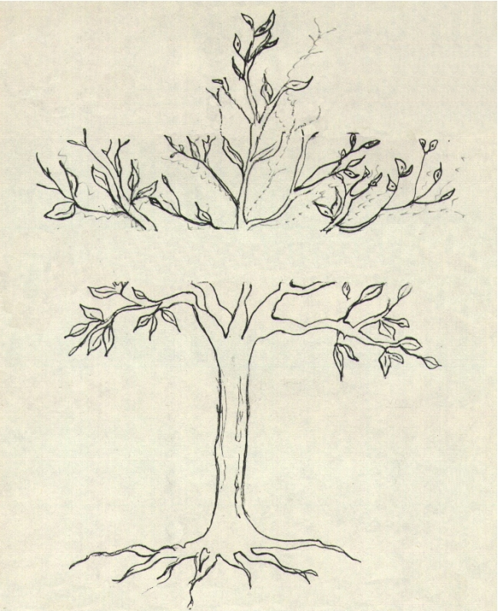
Physio-epistemological foundation of a New Mastership

-Reversible Geometry of the Tree of Knowledge-

Area of critical fluctuation

–The foundation of the new Mastership is not a theory of knowledge, but physio-epistemology of knowing, that is, the discovery of universal laws implied in development of human life.

Area of Critical Fluctuation

On the stream of energy/consciousness ascending through the “tree of knowledge” we discover an “area de critical fluctuation”, where a “new” structure/function, a new dynamic configuration of knowledge-and-life can start. In other words, it is an “area of passage” where the potential involved in the tree of knowledge can pass to outer forms of the “tree of life”.

On the evolutionary development of knowledge of our young students we see a critical threshold of this kind at about the age of 15-17 (the end of the mean teaching cycle) when, previous to a dangerous break between thinking and feeling, by catalytic contact with teachers coming from the future, a young soul can create in itself a new reversible structure of knowledge-and-life.

New Initiation

It is this “catalytic” contact of human encounter that I call “initiation” in the way of Mastership.

Aspirants to new teachers and new leaders begin in their childhood. They retrieve for themselves the mystery that children someday had in entering the school, a missing “school initiation”. In the old school, the initiation in the mystery of knowledge (now replaced with mass information), in the new University passes to a higher level –initiation in the mystery of life.

Suddenly the young man or woman is before a threshold hard to cross. Present educational system does not give any help for that qualitative jump of energy/consciousness demanded by the new co-evolutionary development stage, and young persons of our time have to pay a too heavy price because they stay stationed in front of a rampart that blocks the way to creative forces of life, and dangerously pushes downward to dark abysses of drugs, crime and conformism.

Gen-ethics of the University Process of Synthesis

The University of Synthesis is born as “capsule of inwardness”, germination nucleus by implosion of creative forces.

Its gen-ethical foundation is not a new pedagogic theory –it is a state of consciousness and a new function of life.

Which is its “measure”. –The very man (human canon). It does not aim at a great organisation (mass university) –its inspiration is certain “miniaturisation” paradigm: “small is big” (Schumacher).

Which is its place in the educational system? –The “centre” of all schools, “catalytic nucleus” of all processes of cultural and social development.

How does it work? –By implosion, radiation of energy, and expansion of consciousness.

How is its configuration? –A dynamic form determined by social participation and expanded by individual consciousness. Its “atomic heart” is the university residence. Its “organic body” is the entire society.

Pedagogy of “Humanisation” in the New Ecological Age

This pedagogy integrating knowledge-and-life is based upon the potential development of the human life. Its teaching/apprenticeship instruments rest on holo-epistemology of consciousness-raising and methodology of participation.

- Holo-epistemological Principles of Consciousness-raising

- Expansive/implosion of knowledge-and-life.
- Resonance by similarity.
- Reversibility of values.
- Egoencia of being.

Expansive/implosion

–By transmutation of matter, release of energy, and expansion of consciousness.
–Foundation of “human energ-ethics”.

Resonance by similarity

–Vibrational language (breaking the cosmic barrier).
–Foundation of a new language of human communication.

Reversibility of values

–Stops the “entropic fall” in the anthill; impedes crystallization of life in a form.
–Foundation of “creative gen-ethics (Matchett’s matter/energy/meaning).

Egoencia of being

–Self-consciousness. Transcendent/individuality.
–Foundation of human/divine participation mystique.

- Methodology of Participation

Direct “contact” of being with the soul of phenomena that this soul wants to know. Intermediaries between teacher and pupil disappear. Convergence between intellectual intuition, artistic sensibility and scientific experimentation.
Appreciation of formation in “students/apprentices” as a basic level to follow professional careers: social practice and intellectual knowledge integrated.
When the way of knowledge unites with the way of life, one not only participates in producing material goods, but also we enjoy our participation in goods of the soul (a new dimension in human economy).

Principles of Programmatic Instrumentation

1. The University summons creators of planetary culture of synthesis in the twenty-first century.

A call to educators with vocation to teach the art of integrating knowledge-and-life (in or out of university or school curricula), and young students of the world willing to inhabit the new uni-versity community of knowing-and-being.

2. Planetary convergence pole of human values.

If the United Nations University (UNU), in Tokyo, Japan, is born as an expansive field of scientific-technical knowledge on level of experts, it is urgent to constitute a complementary pole by implosion of the souls of young students of the world, so that the sap circulating through the tree of knowledge may incorporate itself into the tree of life.

- Physio-ecology in the teaching/apprenticeship process.

When the “total” human being gets involved in the teaching/apprenticeship process by social praxis of reversible values, he constitutes not only a productivity link in the chain of terrestrial economy, but even a “resonance particle” in cosmic physio-ecology.

LOOKING AT THE TWENTY-FIRST CENTURY

Now we cannot continue on straight line.

Now we cannot close the eyes.

Life is threatened in the planet.

Perhaps we went too far by leaving our responsibilities for preserving life in hands of scientists, politicians and Academies.

The fragmentation paradigm of knowledge is now in crisis, and the unity of knowing cannot be made any more by science but by man.

Now it is time to handle personally the creative forces of life!

With which tools?

–Logotechnical tools.

These tools still are non-existent, we should create them! Not with fire stolen from gods, but with intelligent co-operation with gods (co-evolutionary function of the “homo creator”). Now the new tools are not only a technical instrument, but also a logotechnical circuit. Now it is not a tool outside man –this tool is man himself.

The new pedagogy has to teach how to use these “logotechnical” tools. Now there is no division between human function creating the tool and the tool that configures a new function.

How to configure these logotechnical circuits in the uni-versity praxis? Which are their functions?

The first circuit is of “comprehension”. It operates by living together in the university residence. Its function is to awaken sense of community.

The second circuit is an “energising” circuit. It operates by ecological practice. Its function is to awaken sense of cosmic ownership.

The third circuit is of “social consciousness”. It operates by practical social work. Its function is to incorporate sense of social responsibility into individual life.

The fourth circuit belongs to “integrated knowledge”. It operates by expansive/implosion of knowledge. Learning how to “dissolve” ideology of knowledge and giving way to “creative wisdom of life”. Its function is to re-establish the universal language.

Previous to learning sciences, learning the language of science.

Previous to acquiring practice in arts, learning the language of arts.

Previous to exercising, exercising the language of work.

Previous to practising philosophical and theological speculation, learning the language of the soul.

Suggestions about design, programs and organisation

This proposition about “University of Synthesis” emerges as “model zero”; it is not a reformation –it is something new.

Two years of “university residence “can awaken certain feeling of understanding, friendship and solidarity among young men and women of the world, which may be higher than all those attempts to improve human relations through diplomatic or cultural ways among different countries of the Earth. After two years of living together and common work and reflection, the young student can at least learn a second language, a complete profession and humane formation that shall enable him not only to fulfil more efficiently his chosen profession, but also, over and above, to respond in a suitable way to labour mobility and social insecurity of a world that is more and more unstable.

In the informatics workshop, he shall learn information language and also the use of knowledge already acquired by humanity, so that he may be in a better position to develop the intuitive mind and expansion of cosmic consciousness.

In the creativity workshop, he shall learn how to relate languages of science, literature, art and technique to inner processes of his own living, by building a bridge –that still is non-existent– between results of the research and development of consciousness, between laws of the universe and laws of man.

In social practice, he shall learn how to participate in lives of those who suffer and of those who work with their intelligence and hands, and how to participate in worries and troubles both of rich and poor persons. He shall learn a complete profession and the rest of practical things for living, that is, cooking, attending a childbirth, helping a wounded man or woman, or assisting dying persons.

In the meditation hall, he shall learn how to know the inner Silence, which goes beyond religious doctrines that divide human beings, and prepares the soul to unite with the mystery of the Unknown and Transcendent.

These two years of “residence” can be a formative basis of the “University professorship career” for all levels of educational systems. At the end of the training period, the student may be given his training diploma, so that this may open opportunities for work and social activities in different areas of the world, something like an “international baccalaureate”. In case of support by some world prestigious institution, these new professionals would get the rank of true “multipliers” of the scientific, social and spiritual message for the emerging culture of synthesis of the twenty-first century.

Bibliographic References

Muñoz Soler, Ramón P., “Germes de Futuro no Homem” (Editora de Cultura Espiritual, Sâo Paulo, 1978) “Anthropology of Synthesis” (Depalma, Buenos Aires, 1980).
“University of Synthesis” (Depalma, Buenos Aires, 1984).

Lazarte, Omar R., “Uma nova dimençao de vida” (Editoral, Sao Paulo, 1980).

Capra, Fritjof, “The Tao of Physics” (Bantam Book, 1975).

Capra, Fritjof, “O ponto de mutaçao” (Cultrix).

Ortolani, Valerio, “Personalidad ecológica” (Universidad Iberoamericana, México, 1986).

